1 June 2023

Denna Lindsay Kelsey & Shayla Krystal Kelsey-Jones & others
7 Verel Street
Fairfield
Hamilton 3214

Dear Denna Kelsey

Pool Monitoring Inspection
Reference Number: 2017/3872
Property Address: 9 Carlson Crescent Silverdale Hamilton 3216

Evidence supplied to Compliance & Monitoring on 01 June 2023 has found that your pool barriers (fences, walls, gates and doors) comply with the Building Act 2004.

Over time it is possible that changes to your garden and and/or pool surrounds may compromise the compliance of your pool barriers. Please note that it is the responsibility of the pool owner to ensure that barriers continue to comply. In particular, please check that the springs and latches of the pool gates are maintained to ensure that they remain in good working order.

Please note that due to changes in legislation on 1 January 2017, all residential pool barriers are now required to be inspected every three years to ensure they continue to meet the requirements of the Building Act 2004. Your next pool barrier inspection will be in three years’ time.

If you have any queries, please contact us on building.unit@hcc.govt.nz.

Yours faithfully
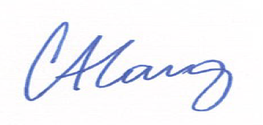
Cory Lang
Building Control Manager
Municipal Offices
Garden Place, Hamilton
www.buildwaikato.co.nz

www.legislation.govt.nz Building Act 2004 Section 162C and 162D - WBCG: LIN_13 Pool Inspection – Compliant

